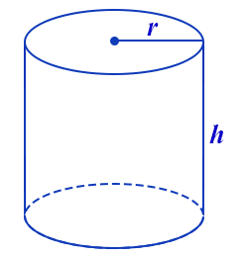
Notes - Volume of Cylinder
A cylinder is a 3-dimensional object with a net made of 2 circles and a curved rectangle.

In order to calculate the volume a cylinder, you will need to:

- Calculate the area of its base
(the base is a circle so, A = πr²)

- Multiply the base area (BA) by the height of the prism.

The formula for volume of a cylinder is:
V = πr² x h
V = area of circle x height of prism
OR

Volume is always expressed in cubic units because it is 3-dimensional. Ex. 10 cm³

Example: Find the volume of this cylinder.
Show your work:
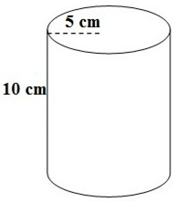
Formula: V = BA x h
V = πr² x h
V = 3.14 x 5² x 10
V = 3.14 x 25 x 10
V = 785 cm³

Practice: Find the volume of this cylinder.
Show your work:

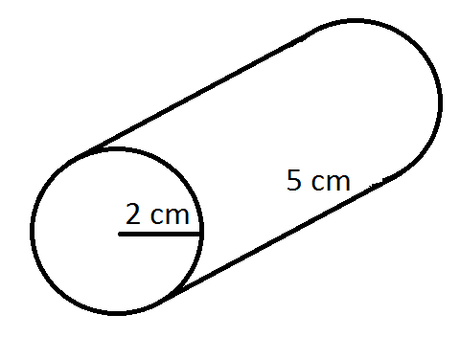
Formula:

